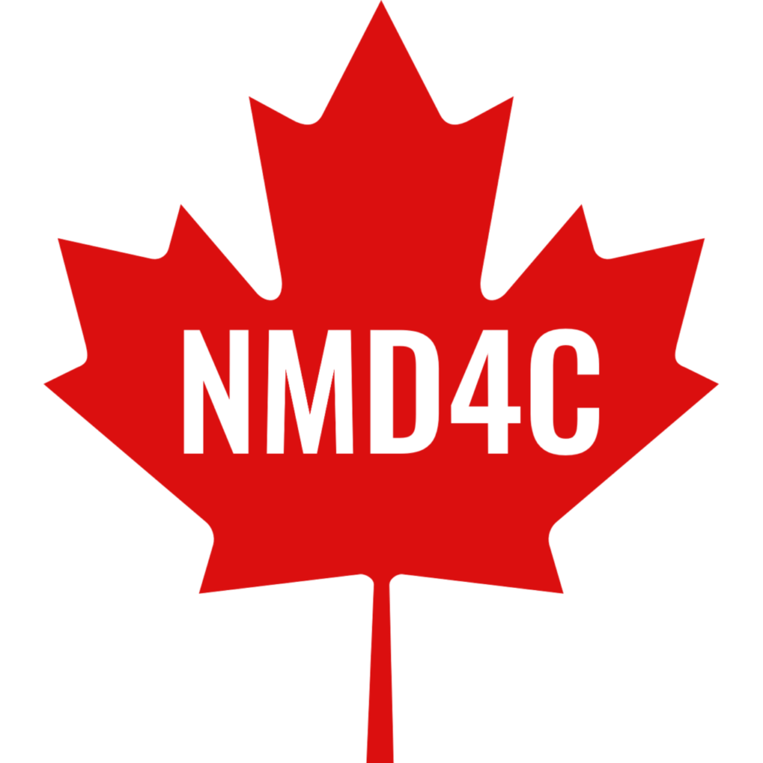
2027 NMD4C–RARE.Qc Basic Science Research
Summer School
APPLICANT’S SUPERVISOR APPROVAL FORM
NMD4C will host our fourth Basic Science Research Summer School for neuromuscular research trainees from May 12–14, 2027, at the Université du Québec à Trois-Rivières (UQTR), led by Dr. Jean-Philippe Leduc-Gaudet. The 2027 Summer School will be organized in partnership with RARE.Qc, bringing together the expertise of both of our networks to support the next generation of basic science researchers working on neuromuscular/rare diseases. Supporting preclinical trainees and scientists is a key priority of both networks, and we aim to make this event as accessible as possible to trainees from across Canada. There will be no registration fee, and financial support will be available to cover economy travel and accommodation costs in Trois-Rivières, Québec.
Our three-day summer school combines scientific lectures, trainee presentations, poster sessions, networking opportunities, and hands-on laboratory workshops. The first day focuses on the journey from basic science to translational research, featuring presentations from leading researchers, patient partners, and industry representatives on topics including inflammation, advanced cellular and molecular approaches, microscopy, flow cytometry, metabolomics, and mitochondrial bioenergetics. The second and third days emphasize practical, experiential learning through hands-on training in state-of-the-art experimental techniques. More details are available here: 2027 Summer School.
PLEASE NOTE:
- For an applicant to be eligible to attend the summer school, we require the approval of the applicant’s supervisor as a part of their application. Please provide your approval below.
Approval is granted for: Click or tap here to enter text.
to attend the 2027 NMD4C–RARE.Qc Basic Science Research Summer School for neuromuscular research trainees from the 12-14 of May 2027, at the UQTR.
SUPERVISOR INFORMATION
Supervisor Name: Click or tap here to enter text.
Supervisor Email: Click or tap here to enter text.
Supervisor Signature: Click or tap here to enter text.
Date: Click or tap to enter a date.

