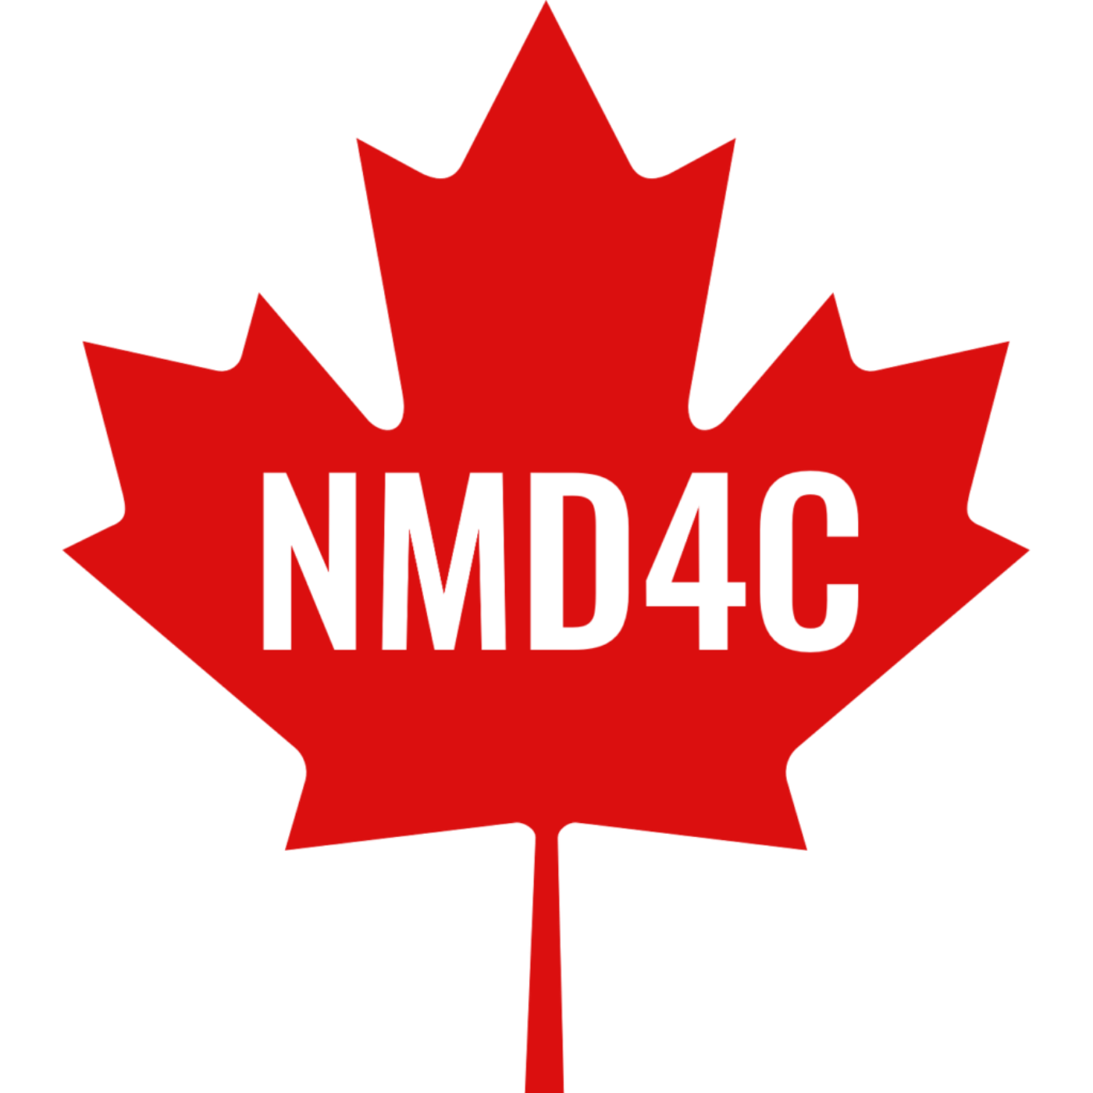
2027 NMD4C–RARE.Qc Basic Science Research Summer School
APPLICANT’S SUPERVISOR APPROVAL FORM
NMD4C will host our fourth Basic Science Research Summer School for neuromuscular research trainees from May 12–14, 2027, at the Université du Québec à Trois-Rivières (UQTR), led by Dr. Jean-Philippe Leduc-Gaudet.
The 2027 Summer School will be organized in partnership with RARE.Qc, bringing together the expertise of the both of our networks to support the next generation of basic science researchers working on rare diseases, such as neuromuscular disorders. Supporting preclinical trainees and scientists is a key priority of both networks, and we aim to make this event as accessible as possible to trainees from across Canada. There will be no registration fee, and financial support will be available to help offset travel and accommodation costs in Trois-Rivières, Québec.
The program will cover workshops Inflammation and Assessment of mitochondrial function as well as sessions on Basic Science to Translational Research on Day 1; Hands-on Experimental Training on Day 2; and on Day 3.
Click to View More Info on our Website

PLEASE NOTE:
- For an applicant to be eligible to attend the summer school, we require the approval of the applicant’s supervisor as a part of their application. Please provide your approval below.
Approval is granted for: Click or tap here to enter text.
to attend the 2027 NMD4C–RARE.Qc Basic Science Research Summer School for neuromuscular research trainees from the 12th to 14th of May 2027, at the Université du Québec à Trois-Rivières (UQTR).
SUPERVISOR INFORMATION
Supervisor Name: Click or tap here to enter text.
Supervisor Email: Click or tap here to enter text.
Supervisor Signature: Click or tap here to enter text.
Date: Click or tap to enter a date.

