Clinical practice guideline adaptation process

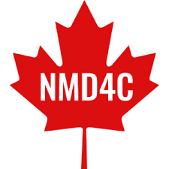

Introduction
Evidence-based medicine, which is making clinical decisions based on scientific evidences, is the new medical approach and require evidence-based clinical practice guidelines (CPGs). These CPGs are developed through a highly rigorous, time-costing and resources-consuming process, but are not adapted to any local contexts. The adaptation of existing CPGs for local circumstances is critical to promote local applicability and implementation and may overcome the lack of mandatory equipment or staff for guidelines’ recommendations.
Relying on a well-defined adaptation process might end up reducing both costs and time, and ensure no duplication of CPGs are done. In addition, using a systematic participatory approach for CPGs adaptation, such as the process detailed in this document, might help prevent from evidence-base integrity weakening.

The INESSS-ONF Guideline Development Process
The Canadian INESSS-ONF Guideline Development Process, a six steps adaptation process based on engaged interdisciplinary end-users, has been already tested in neurological disorders (Figure 1). It was selected for NMD4C CPGs adaptation as it allows a better understanding of the needs and barriers to overcome the knowledge-to-action gaps. Below are the chronological steps for adapting CPGs.
- Scoping review in bibliographic databases and disease-related websites and individual evaluation of CPGs
- Validation of the needs and expectations among the targeted audience
- Synthesis of the documentation and evidence
- Coordination of a consensus amongst expert
- Adaptation of the CPG
- Publication and implementation of the CPG
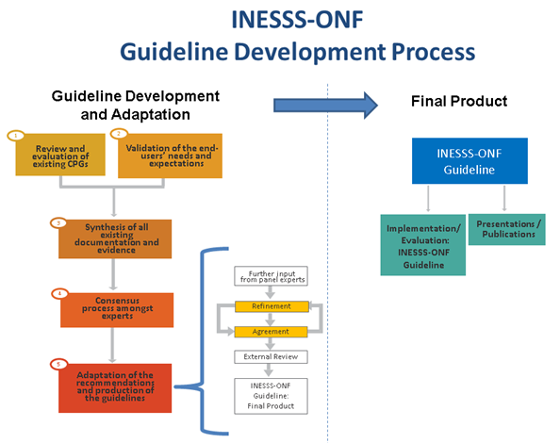
Figure 1. INESSS-ONF Guideline Development Process flowchart

Selection of topic and end-users
There are a few pre-processing steps prior to adapting CPGs which were not discussed in the INESSS-ONF Guideline Development Process. The identification of the needs and feasibility of the guidelines might have been discussed in detailed as it is one of the most important starting points. Accordingly, a steering committee, regrouping a multidisciplinary team with at least one member of the working group, should be set up in the first instance. The first meeting should include a discussion of the needs for the CPG, the feasibility of the adaptation, the suggested experts within the field, financial needs, a well-detailed work plan with a timeframe and the definition of each member’s role (Mwangi et al. 2018). Based on the stakeholders’ needs, the specific topic and clinical questions should be clearly defined among the steering committee.

Scoping review in bibliographic databases and disease-related websites
NMD4C has established a specific procedure for the scoping review of existing CPGs: a 3S strategy (Searching, Screening, Selecting), presented in the Figure 2.
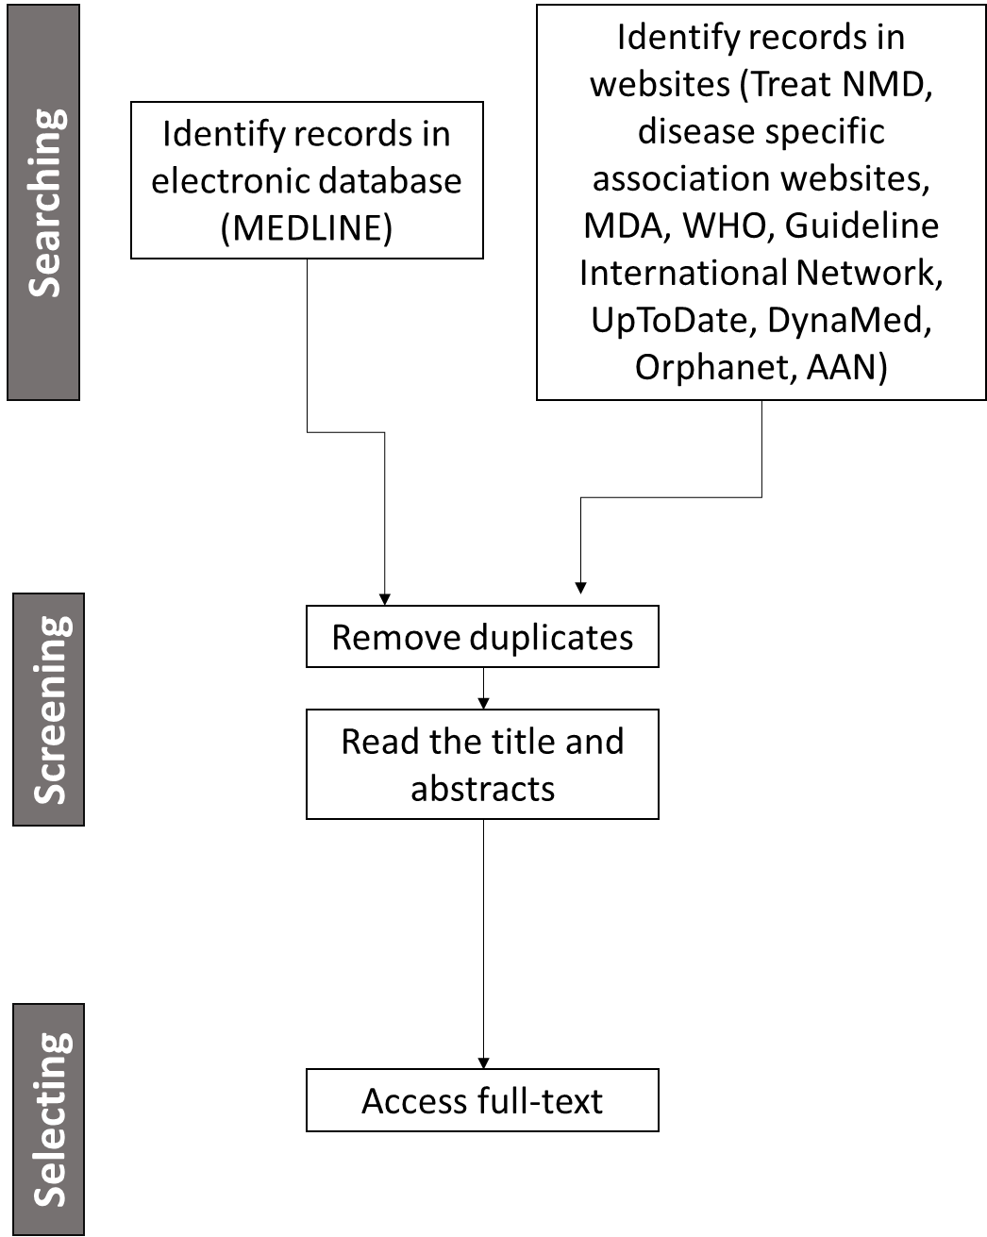
Figure 2. The 3S strategy for CPG scoping review from searching to selecting existing CPGs.

MEDLINE electronic database search
The identification of CPGs within the MEDLINE database should be based on a a priori defined literature search process. The search key concepts must include Clinical Practice Guidelines, the topic of interest, screening and management. The Table 1 present an example of search terms.

Table 1. Search terms for the MEDLINE electronic database literature scoping review using SMA recommendations for physiotherapists as an example
Clinical guidelines | Spinal muscular atrophy | Screening | Management
guideline*  clinical practice guideline*  CPG  practice guideline*  consensus  development consensus statement*  clinical decision-making  clinical protocol  evidence-based guideline*  practice protocole  practice pattern  practice parameter | juvenile spinal muscular atrophy  muscular atrophy, spinal  juvenile spinal muscular atrophies  Werdnig-Hoffman syndrome  Werdnig-Hoffman disease  adult spinal muscular atrophy  spinal muscular atrophies of childhood  adult spinal muscular atrophies  Kugelberg-Welander syndrome  Kugelberg-Welander disease  intermediate spinal muscular atrophy  intermediate spinal muscular atrophies | examination  physical examination  clinic  risk factor  risk assessment  risk reduction  behaviour  diagnosis  classification  evaluation  screening | care  treatment  follow-up  prevention  prognosis  patient experience  management  monitoring  self-management  patient education  exercise  physical adaptation  home adaptation  occupational therapy  injury management  pain therapy  rehabilitation  condition’s evaluation  condition’s assessment  device* needs evaluation  device* needs assessment

Disease-related relevant websites search
The websites selected for the identification of records must be about rare, muscular or neurological diseases, neuromuscular diseases in general or one in particular (e.g. www.curesma.org), list the different CPGs published, or be governmental or international health bodies. For example, here is a list for SMA CPG websites-based search:
- Treat NMD
- CureSMA Canada
- MDA
- WHO
- Guideline International Network
- UpToDate
- DynaMed
- Orphanet
- AAN

Screening and Selecting CPGs for the adaptation process
The sorting of existing CPGs is based on certain pre-established criteria that are quickly evaluated using the title, abstract and a quick reading of the article. All the guidelines that did not meet the predefined criteria must be removed At the end of the screening and selection of CPGs, all the publications must be dated after 2000, written in English, include evidence-based recommendations and must be accessible in full-text.

Individual evaluation of CPGs
Following the scoping review for existing CPGs, a careful assessment of each one must be carried out in accordance with the Appraisal of Guidelines for Research and Evaluation II (AGREE II; http://www.agreecollaboration.org) process to ensure that only those with a high evidence-base quality level are selected. The AGREE II process is a 23 items evaluation tool divided within six-domain for assessing the quality of existing guidelines. The evaluation steps include (a) Score and purpose, (b) Stakeholder involvement, (c) Rigour of development, (d) Clarity of presentation, € Applicability, and (f) Editorial independence. Each guideline will be attributed All guidelines will be given a score on a 100-point scale, with 1 being the lowest quality level and 100 being the highest. Scores will be discussed in a steering committee until a consensus is reached on which GICs will be included in the adaptation process. As there are no pre-existing thresholds of high-quality guideline’s indication in the AGREE II instrument, only guidelines which scored at least 75% were considered high-quality and were retained for further adaptation.

Validation of the end-users' needs and expectations
To assess the needs and expectations, a survey must be set up and sent to the targeted end-users. The survey must be sent to the maximum possible multidisciplinary stakeholders. It must ensure that it assesses the level of use and knowledge of the selected CPGs, the subject which should be covered with the adapted CPG and the suggested implementation strategies which should be considered. This step is critical to identify the top-priority topics of the CPG, the format of the tools and the best implementation plan.

Synthesis of all existing documentation and evidence
The next step is to evaluate the content of each CPG. Accordingly, a recommendations matrix should be applied to each high-quality recommendation relevant to the selected topic. This matrix must assess the level of evidence and grade of recommendations of each existing statement to facilitate the further deliberations about the inclusion of the recommendations in the adapted CPG. To do so, each recommendation was given both a level of evidence (A, B or C) and a grade of recommendation (1=strong or 2=weak). With such a table, differences between CPGs might be highlighted and it will help adopting the higher evidence-based recommendations.

Coordination of a consensus amongst expert
A coordinated multidisciplinary team then should be synchronously or asynchronously brought together to discuss the recommendations raised in the previous steps and underscore the missing ones. As neuromuscular diseases are generally classified among the rare diseases where knowledge is quite rare and level 1 quality evidence is lacking, it is critical to add expert and stakeholders insight and experiences to the evidence bases within the guideline (Pai et al. 2019). A team of 4-5 types of experts is recommended for this step and should include (1) disease experts, (2) professionals with knowledge of specific problems, impairments or symptoms of a similar rare disease that may be applicable, (3) professionals in practice or discipline, (4) patients and their families/caregivers, and (5) context-related experts (e.g. teachers, employers, community services) (The ADAPTE Collaboration 2009). The INESSS-ONF process suggest to physically hold a conference to discuss the evidence-based recommendation and to generate new ones based on research and expertise. Several other methods can be recommended to ensure that the maximum amount of knowledge and insight is obtained from the experts: content analysis, case study, interview, task analysis/observation, Delphi, case scenario.

Adaptation of the recommendations and production of the guideline
The recommendations that emerged from the expert consensus should then be adapted, refined and compiled. The INESSS-ONF process suggests a 2-rounds online survey to (1) identify the recommendations which should be included in the adapted CPG and, (2) the most relevant recommendations which should be highlighted in the implementation stage. Only recommendations agreed by ≥80% of the experts’ panel should be included in the adapted CPG. The draft version of the adapted CPG must include survey-based “priority” and “fundamental” recommendations. Fundamental recommendations must be set up as the system basis, whereas priority recommendations were the ones highlighted as the most important for implementation and monitoring.
The draft version of the adapted CPG must include a brief rationale for each recommendation, systemic aspects, structure and process markers, and suggested tools. Each section should also be accompanied by a summary of supporting evidence. Structure and process markers will have to be identified during the expert consensus stage where they should propose indicators for each section of the CPG.
The draft of the CPG must therefore be reviewed by an external group of experts and stakeholders, and organisational policy makers to assess both the validity and relevance of the recommendations before proceeding to the final version. Obtaining feedback on the recommendations ensures that end-users will be open to using the CPG and also helps identify potential barriers to implementation. This use of external reviewers also serves as the first dissemination of the new CPG.

Implementation of the CPG in clinical settings
While there are many detailed processes for adapting a CPG, dissemination and implementation are often overlooked or even excluded, which is reflected by a number of recommendations that remain unapplied. It seems essential to identify beforehand the potential obstacles that may hinder the adoption and/or adherence of the recommendations. These barriers can be classified into three broad categories: knowledge barriers, attitudinal barriers and external barriers. Although the INESSS-ONF guideline development process does not adequately document the detailed process to be adopted to carry out the dissemination and implementation of the adapted CPG, there are several articles in the literature that give a good idea of the plan to be adopted for an effective and time-saving implementation strategy. A six-steps plan to implement the recommendations was developed according to the following actions points : (1) assess needs, (2) define objectives, (3) develop practical strategies, (4) plan the programme, (5) adopt and effectively implement recommendations, and (6) evaluate implementation (Bartholomew, Parcel, and Kok 1998; Zwerver et al. 2011).
Based on current implementation strategies, it seems relevant to set up a multi-faceted plan that advocates combined active and passive dissemination approaches (Grol and Grimshaw 2003; Huynh et al. 2018; Green et al. 2007; van der Wees et al. 2008; Grimshaw and Russell 1993; Grimshaw et al. 2012; Storm-Versloot et al. 2012). This plan could therefore include local health coordination, conferences, training material, professional associations presentations, scientific and social media publications, and dissemination of print material. In any case, implementation and adherence to new recommendations is not necessarily immediate, so it may be preferable to monitor implementation over several years.

References
INESSS-ONF. INESSS-ONF Guideline Development Process [Internet]. 2020 [cited 2020 Aug 19]. https://braininjuryguidelines.org/modtosevere/methods/steps/
AGREE Next Steps Consortium. Appraisal of guidelines for research and evaluation II: AGREE II instrument [Internet]. 2013 Sep [cited 2020 Aug 19]. http://www.agreetrust.org/wp-content/uploads/2013/10/AGREE-II-Users-Manual-and-23-item-Instrument_2009_UPDATE_2013.pdf.
Bartholomew, L. K., G. S. Parcel, and G. Kok. 1998. 'Intervention mapping: a process for developing theory- and evidence-based health education programs', Health Educ Behav, 25: 545-63.
Green, Lee A., Leon Wyszewianski, Julie C. Lowery, Christine P. Kowalski, and Sarah L. Krein. 2007. 'An observational study of the effectiveness of practice guideline implementation strategies examined according to physicians' cognitive styles', Implement Sci, 2: 41-41.
Grimshaw, J. M., M. P. Eccles, J. N. Lavis, S. J. Hill, and J. E. Squires. 2012. 'Knowledge translation of research findings', Implement Sci, 7: 50.
Grimshaw, J. M., and I. T. Russell. 1993. 'Effect of clinical guidelines on medical practice: a systematic review of rigorous evaluations', Lancet, 342: 1317-22.
Grol, R., and J. Grimshaw. 2003. 'From best evidence to best practice: effective implementation of change in patients' care', Lancet, 362: 1225-30.
Huynh, A. K., A. B. Hamilton, M. M. Farmer, B. Bean-Mayberry, S. W. Stirman, T. Moin, and E. P. Finley. 2018. 'A Pragmatic Approach to Guide Implementation Evaluation Research: Strategy Mapping for Complex Interventions', Front Public Health, 6: 134.
Mwangi, Nyawira, Muchai Gachago, Michael Gichangi, Stephen Gichuhi, Kibata Githeko, Atieno Jalango, Jefitha Karimurio, Joseph Kibachio, Lawrence Muthami, Nancy Ngugi, Carmichael Nduri, Patrick Nyaga, Joseph Nyamori, Alain Nazaire Mbongo Zindamoyen, Covadonga Bascaran, and Allen Foster. 2018. 'Adapting clinical practice guidelines for diabetic retinopathy in Kenya: process and outputs', Implementation Science, 13: 81.
Pai, M., C. H. T. Yeung, E. A. Akl, A. Darzi, C. Hillis, K. Legault, J. J. Meerpohl, N. Santesso, D. Taruscio, M. Verhovsek, H. J. Schunemann, and A. Iorio. 2019. 'Strategies for eliciting and synthesizing evidence for guidelines in rare diseases', BMC Med Res Methodol, 19: 67.
Storm-Versloot, M. N., A. M. Knops, D. T. Ubbink, A. Goossens, D. A. Legemate, and H. Vermeulen. 2012. 'Long-term adherence to a local guideline on postoperative body temperature measurement: mixed methods analysis', J Eval Clin Pract, 18: 841-7.
van der Wees, P. J., G. Jamtvedt, T. Rebbeck, R. A. de Bie, J. Dekker, and E. J. Hendriks. 2008. 'Multifaceted strategies may increase implementation of physiotherapy clinical guidelines: a systematic review', Aust J Physiother, 54: 233-41.
Zwerver, F., A. J. Schellart, J. R. Anema, K. C. Rammeloo, and A. J. van der Beek. 2011. 'Intervention mapping for the development of a strategy to implement the insurance medicine guidelines for depression', BMC Public Health, 11: 9.
The ADAPTE Collaboration. The ADAPTE Process : Resource Toolkit for Guideline Adaptation. Version 2.0 [Internet] 2009 [cited 2020 Aug 19]. http://www.g-i-n.net

